Writing effective alt text
It is essential to provide appropriate alternative (alt) text for images. Without them, when the text-to-speech function of an eReader reads an image that doesn’t contain any alt text, a reader will just hear all types of text put in place of alt text you provided, including “image,” “graphic,” “figure,” or “null” depending on the system being used.
An image description should convey equivalent information, and serve an equivalent purpose, to that of the image. Image descriptions can be provided in 2 forms:
- alternative (alt) text — that is, a brief description — for images that are simple or of medium complexity; and
- alt text with an additional long description for complex images.
The image description should provide the equivalent content and function to that of the image, so that a reader listening to the description receives the same key information as the reader who can see it.

Be succinct
People with low or no vision experience greater strain on their working memory than sighted people when processing images. To ensure image descriptions are useful:
- Keep alt text brief.
- Break information and concepts into succinct sentences or lists.
- Omit details that are unimportant, irrelevant, or potentially distracting.
- The ideal length for alt text is approximately 280 characters, so as to not burden reading.

Avoid repetition and redundancy
Provide each piece of information only once. Do not repeat in the alt text and long description anything that is already in the body text, figure title, or caption.

Be objective
Describe the graphic objectively. Do not:
- make judgements or assumptions;
- attempt to interpret the image; or
- water down or censor content in the description.
Describe only what can be seen in the image. For example, the image below is in black and white, and we can see only the outline of the surfer. It is not possible to make an accurate statement about the location, weather, or time of day.
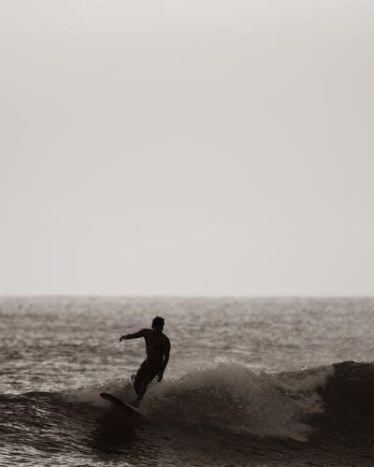

Steps for drafting image descriptions
When drafting image descriptions, consider the purpose of the image, the order of information, and the level of detail required.

Move from the general to the specific
Provide an overall description in the alt text. You can then provide more detail in a supplementary long description if further information is needed.

Alt text
Use the alt-text to “set the scene.”
Alt text: A two-story building featuring a large mural with the words “Bondi Beach” in the middle.

Long description
Use the long description to provide additional details if these will help the reader understand the image better:
- Provide the details in a logical order.
- Follow this order consistently rather than jumping around the image.
- Separate information about each element into easily digestible parts, such as by using short sentences or line breaks.
Alt text: A two-story building featuring a large mural with the words “Bondi Beach” in the middle.
Long description: A wall of a building with two large, arched windows on the ground floor and 2 smaller windows on the upper floor. The wall is covered in a large mural of pictures and words on a white background. The bottom section of the mural lies between the ground-floor windows. It shows two palm trees on a curved beach with the sea behind and birds and the sun above. The central section of the mural is between the lower and upper windows. The words “Bondi Beach” are inside a scalloped oval shape surrounded by a light blue shading. Wrapping around the mural is a red, black, and yellow dragon with large round eyes, long whiskers, and triangular scales down its back. The dragon’s head is between the top-floor windows and its neck curves over the right-hand window. Its tail runs down the right-hand side of the building and curls over the top left-hand corner towards the left window. Flowers and star shapes fill the spaces between the larger graphics.

Decide on the level of detail
The amount of detail to include in the description will depend on:
- the target readership
- the reading objective
- the purpose of the image
- how much information has already been provided in the body text and caption.
It is not necessary to describe every detail in an image. The object is to convey the core information as succinctly as possible.

Photographs
The general principles for describing photographs are:
- If the caption and/or body text are sufficient to describe the photograph, you may need to provide only one or two words of alt text.
- Include any text in the photograph verbatim.
- Depending on the context, the description may also include:
  - the setting or location
  - the surroundings
  - color
  - the orientation of the objects
  - the appearance of people and their clothing.

Alt text: A square parcel wrapped in white paper and tied with a red ribbon. Placed around the parcel are a pair of scissors, green leaves, red berries, a pinecone, and a piece of ribbon. A tag on the parcel reads “Open me.”

Images of people
When describing people:
- Avoid making assumptions or judgements; describe only what can be seen of a person in the image.
- Identify the appearance of people in the image in only as much detail as is useful in the context, such as clothing, hair, skin tone, eye color, and prominent features.
- If a subject’s appearance is not relevant, it may be more useful to keep the physical description to a minimum and focus on what they are doing.
- If physical appearance is described, do so consistently throughout the publication and avoid bias (for example, describing women’s clothing or hairstyles but not men’s).
- Do not use food, beverages, or other objects to describe the color of someone’s hair, eyes, or skin.
- Do not use ethnic terms to describe skin; refer instead to light, medium-light, medium, medium-dark, or dark skin tone.

Gender
The discussion of gender is an evolving and sensitive area. You may make different choices depending on the context in which images are used in your work.
Gender may be mentioned where:
- the person’s gender is verifiable (for example, a famous person or where the subject’s gender is referred to in the text);
- it is clearly being performed in the image (such as an advertisement for men’s fragrance featuring a deliberately “masculine” man); and
- you consider it appropriate to the context (such as in some historical images).
Alt text: A person looking at a laptop screen.
Long description: They have long brown hair and are wearing reading glasses. Their fists are clenched either side of their mouth, gripping the ends of a yellow pencil held horizontally between their teeth. A container of colored pencils is to the left of the laptop.

Works of art
The language used to describe art may be richer and more evocative than for other forms of image description.
- Where possible, base descriptions of an artwork on any statements made by the artist.
- Describe what can be seen in the artwork, including color and texture.
- Describe the style in which the artwork has been created.
- Describe the relationship of objects within the work to one another (for example, to the right or left of the main subject), and their orientation.
- Consider using descriptions that appeal to the senses of sound, touch, smell, and taste to support a richer experience of the artwork (for example, “crashing waves,” “soft sand”).
- Employ simile where comparisons may aid understanding of the work (for example, “long and sinewy like a snake”) without adding ambiguity.
- If the frame of a painting is visible in the image, describe that too.
- Identify whether an image is vertical (portrait) or horizontal (landscape) only if this information may help the reader understand the image.
Caption: Portrait of Joseph Deutz, Michael Sweerts, circa 1648–49. Oil on canvas.
Alt text: Painting of the head and torso of a young man.
Long description: The man has shoulder-length brown hair, brown eyes and light skin tone. He is wearing a brown doublet (jacket) over a loose white shirt with voluminous sleeves. The pleats of the shirt show through a gap in each of the upper arms of the doublet, and at the waist and cuffs. The man’s body is at an angle, his head is turned towards the viewer and his brown eyes look directly at us. His left hand is on his hip and his right hand is held in front of his chest with the palm facing in, as if beckoning us to come closer so he can speak to us. The solid dark brown background is almost the same color as his doublet. A strong light entering the picture from the young man’s right illuminates his shirt, face, and hands. The flashes of his white shirt and light skin form a circle of bright shapes in the picture that contrast sharply with the dark brown of the background and the man’s doublet, hair, and eyes.

Maps
The amount of detail provided will depend on the context and the function of the map. Simple maps or maps for younger readers may only need a short description or summary whereas others will need a greater level of detail and complexity.
- Provide a summary of the map before going into the details.
- Give all labels on the map verbatim.
- Describe the map in a logical, structured way, separating information into blocks.
- Describe labelled areas of land and water, and their relationships to each other, where relevant.
- Use north, south, east, and west to refer to directions (for example, south-west of the city) rather than above, below, right, and left.
- Describe lines as vertical, horizontal, diagonal, curved, and so on.
- Write out units of distance in full (1,000 kilometers, not 1,000 km).
- Include lines of latitude and longitude and their corresponding degrees if appropriate.
- Describe and differentiate colored areas of the map.
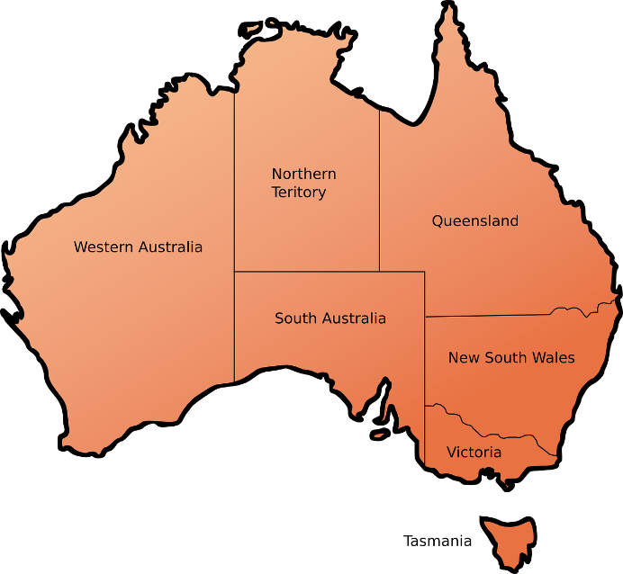
Caption: The state and territory borders of Australia.
Alt text: A map showing Western Australia, Northern Territory, Queensland, New South Wales, Victoria, Tasmania, and South Australia.
Long description: Described clockwise from the west:
Western Australia occupies approximately a third of mainland Australia on the map, stretching from the north to the south coast in the west of the country. It shares its north-eastern border with Northern Territory and its south-eastern border with South Australia.
Northern Territory occupies the center-north section of the mainland. It shares its eastern border with Queensland, its southern border with South Australia and its western border with Western Australia.
Queensland occupies the north-east section of the mainland. It shares its southern border with New South Wales, its south-eastern corner with South Australia and its western border with Northern Territory.
New South Wales covers approximately three-quarters of the south-east section of the mainland. It shares its northern border with Queensland, its southern border with Victoria and its western border with South Australia.
Victoria covers the southern quarter of the south-east section of the mainland. It shares its northern border with New South Wales and its western border with South Australia.
Tasmania is a small island directly south of Victoria.
South Australia occupies the center-south section of the mainland. It shares its western border with Western Australia, its northern border with Northern Territory, its north-eastern corner with Queensland, its mid-eastern border with New South Wales and its lower-eastern border with Victoria.

Tree diagrams
When describing tree diagrams:
- Concentrate on the relationships between the elements in the tree rather than the layout of the diagram.
- Give an overall description of the diagram before describing the individual elements and their relationships at each level.
- Use alt-text descriptions for primary school texts, simple bullet lists for high-school and general texts and nested lists only for academic, tertiary, or professional texts.
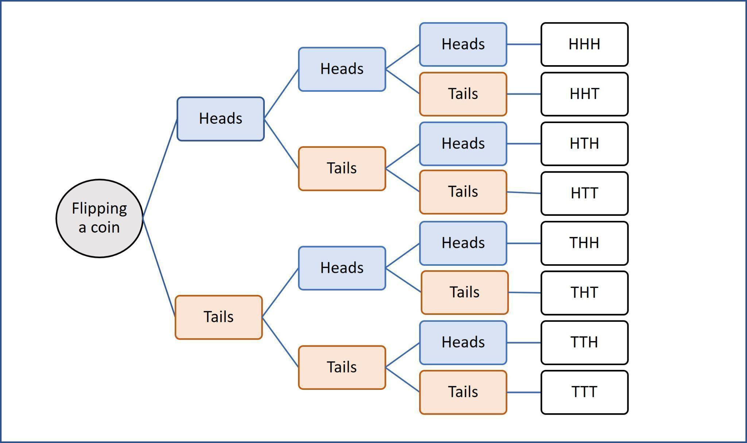
Caption: The possible outcomes of a coin flipped three times in a row.
Alt text: A tree diagram shows eight possible combinations of heads and tails.
Long description: The diagram moves from left to right. Each time the coin is flipped the result is either heads or tails. The possible outcomes of flipping a coin three times are:
- heads, heads, heads
- heads, heads, tails
- heads, tails, heads
- heads, tails, tails
- tails, heads, heads
- tails, heads, tails
- tails, tails, heads
- tails, tails, tails

Flowcharts
Flowcharts can be simple or complex. For all charts:
- Provide an overview of the diagram, including the direction of flow if necessary, before describing the components of the process.
- Establish the start and end points for circular flowcharts, and note if the diagram has more than one start point.
- Describe the main flow routes succinctly.
- Organize the chart into linear, nested lists (bullets or numbered, whichever is best suited to the content).
- Break complex diagrams into multiple descriptions.
- Do not describe the appearance of the chart (such as colors, the shape of arrows and boxes) unless this is relevant. Focus instead on the function of the arrows, using phrases such as “leads to” or “arrow to” and “If no/If yes.”
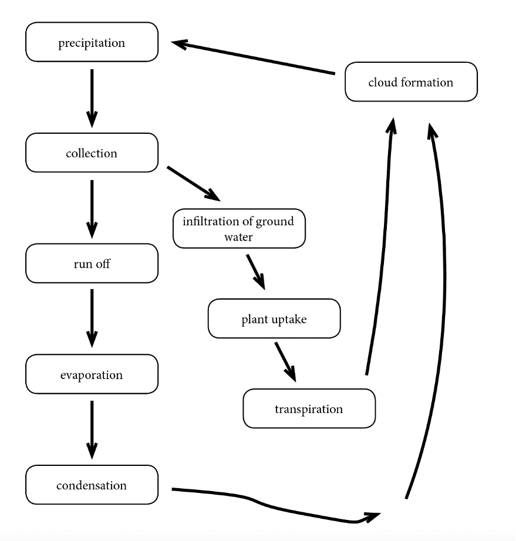
Caption: The water cycle.
Alt text: A circular flowchart shows two routes to cloud formation and precipitation.
Long description: The flowchart leads downwards to a cyclical process. Here the process is described as a nested list of steps that begin and end with precipitation:
- Precipitation leads to collection.
- Collection leads to cloud formation by 2 routes:
- Run off:
- Run off leads to evaporation.
- Evaporation leads to condensation.
- Condensation leads to cloud formation.
- Infiltration of ground water:
- Infiltration of ground water leads to plant uptake.
- Plant uptake leads to transpiration.
- Transpiration leads to cloud formation.
- Cloud formation leads to precipitation.
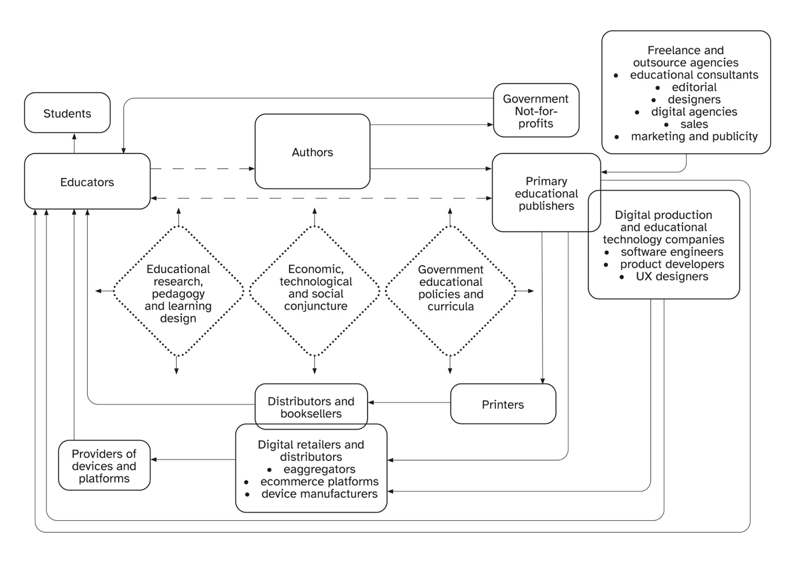
Source: Grace Reid and Agata Mrva-Montoya, “‘Partners in Education’: Primary Educational Publishers’ Understanding of Their Role,” Book 2.0 12, no. 1 (2023).
Caption: The primary educational publishing communication circuit, adapted from Robert Dartons’s communication circle (1982).
Alt text: The diagram illustrates the circular relationship between different stakeholders involved in the educational publishing process as a series of linked boxes surrounding the 3 central forces. The relationships begin and end with educators.
Long description: The middle of the diagram shows the 3 central forces impacting educational publishing:
- educational research, pedagogy and learning design
- economic, technological, and social conjuncture
- government educational policies and curricula
These are surrounded by stakeholders involved in the publishing value chain:
- educators
- authors
- government and not-for-profits
- primary educational publishers
- freelance and outsource agencies
- digital and educational technology companies
- printers
- distributors and booksellers
- digital retailers and distributors
- providers of devices and platforms
Educators lead to:
- students (direct line)
- authors (broken line)
- primary educational publishers (broken line that also points back to educators)
Authors lead to:
- government and not-for-profits
- primary educational publishers
Government and not-for-profits lead to educators.
Primary educational publishers lead to:
- printers
- printers lead to distributors and booksellers
- distributors and booksellers lead to educators
- digital retailers and distributors (e-aggreagators, ecommerce platforms, device manufacturers)
- digital retailers and distributors lead to devices and platforms
- devices and platforms lead to educators
- educators
Freelance and outsource agencies lead to primary educational publishers. These agencies are:
- educational consultants
- editorial designers
- digital agencies
- sales
- marketing and publicity
Primary educational publishers overlap with digital production and educational technology companies, which are:
- software engineers
- product developers
- UX designers
Educational technology companies lead to:
- digital retailers and distributors (e-aggregators, ecommerce platforms, device manufacturers)
- digital retailers and distributors lead to devices and platforms
- devices and platforms lead to educators
- educators.

Graphs, bar charts, and pie charts for general use
When describing charts for texts other than math or science:
- Give an overall description of the graph or chart, including the type of graphic, the main elements or coordinates and a summary of the contents if possible.
- Describe the overall trend in bar charts.
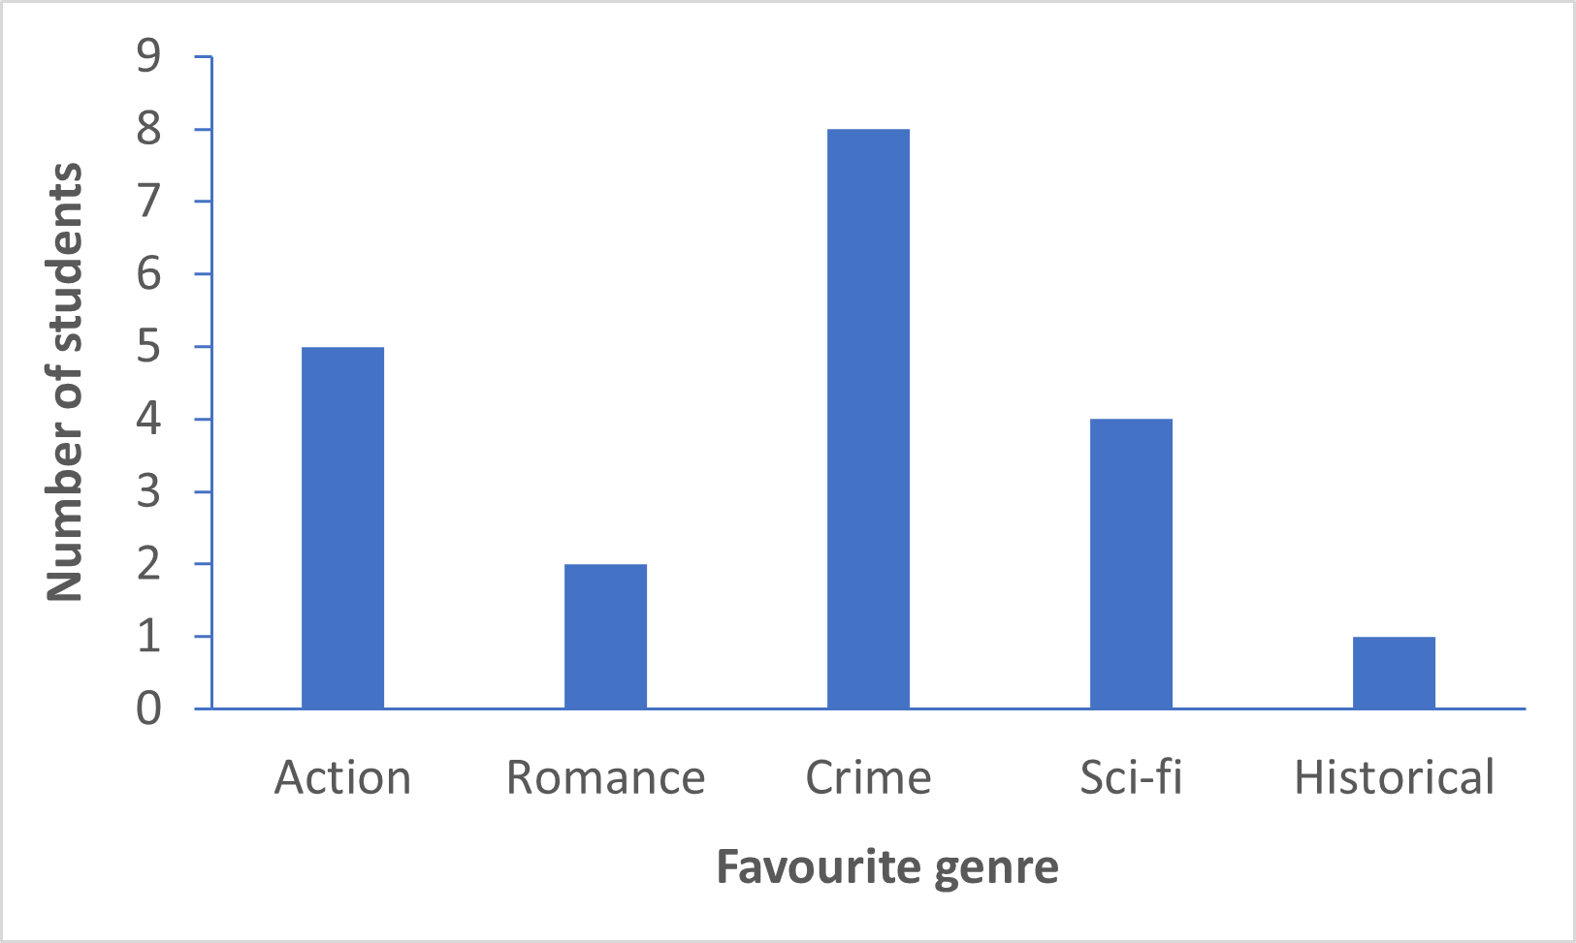

Caption: Types of novels preferred by students in Class 9B.
Alt text: A bar chart shows 5 genres of novel and the number of students who prefer reading each genre. The genres are action, romance, crime, sci-fi and historical. Crime novels are the most popular and historical novels the least.
Long description: The y-axis shows the number of students, ranging from 0 to 9. The x-axis shows the favorite genre:
Action: 5 students
Romance: 2 students
Crime: 8 students
Sci-fi: 4 students
Historical: 1 student
- Provide the axis and any other labels in the graphic. It is not necessary to italicize elements such as x and y.
- If available, use the original data (for example, in MS Excel) as a reference point.
- Provide the data as a bullet list or an accessible table unless the graphic is a simple bar chart, in which case the data can be provided as a simple list (without bullets or numbers).
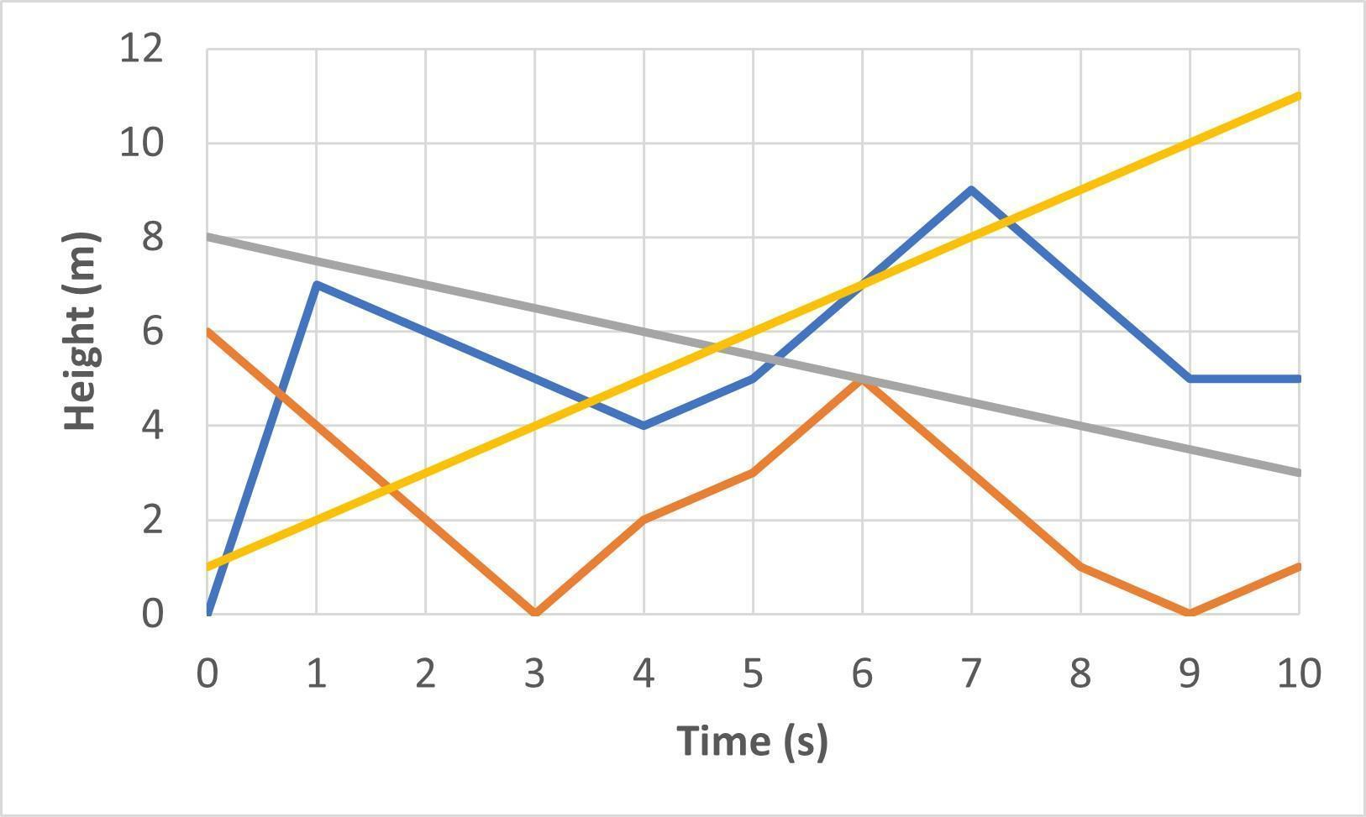
Caption: Bird flights, measured from ground level.
Alt text: A graph shows the vertical movement of four birds over a ten-second span.
Long description: The x-axis shows the time, from zero to ten seconds. The y-axis shows the height, from zero to twelve meters. The data are summarized in the following table:
Time (in seconds) | Bird A height (in meters) | Bird B height (in meters) | Bird C height (in meters) | Bird D height (in meters)
0 | 0 | 6 | 8 | 1
1 | 7 | 4 | 7.5 | 2
2 | 6 | 2 | 7 | 3
3 | 5 | 0 | 6.5 | 4
4 | 4 | 2 | 6 | 5
5 | 5 | 3 | 5.5 | 6
6 | 7 | 5 | 5 | 7
7 | 9 | 3 | 4.5 | 8
8 | 7 | 1 | 4 | 9
9 | 5 | 0 | 3.5 | 10
10 | 5 | 1 | 3 | 11
- List the elements in pie charts from the largest to smallest percentage.
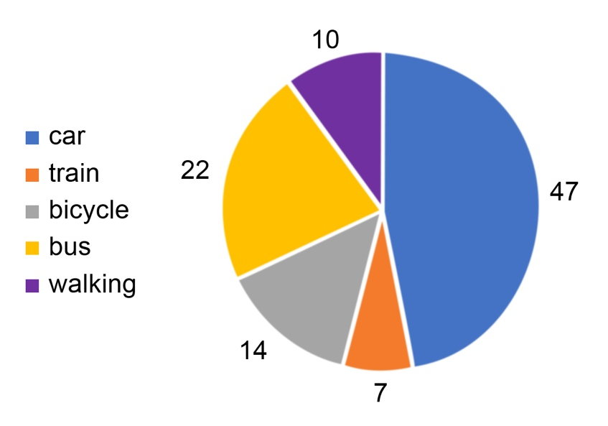
Caption: How employees of BookPages Pty Ltd travel to work.
Alt text: A pie chart showing the percentage of employees using one of five modes of transport.
Long description: The data are summarized in the following table:
Mode of transport | Percentage of employees
Car | 47
Bus | 22
Bicycle | 14
Walking | 10
Train | 7

Graphs and diagrams
Where possible, convert graphs into accessible tables or bulleted lists. If this is not possible, create alt text using the following guidelines:
- Use short sentences.
- Provide an overall description, including the type of graph or diagram (such as “a bar graph” or “a pie chart”), before describing the details or data.
- Focus on the data rather than the appearance of the graphic.
- For graphs describe the axes and key coordinates or elements and provide the data in a bulleted list.
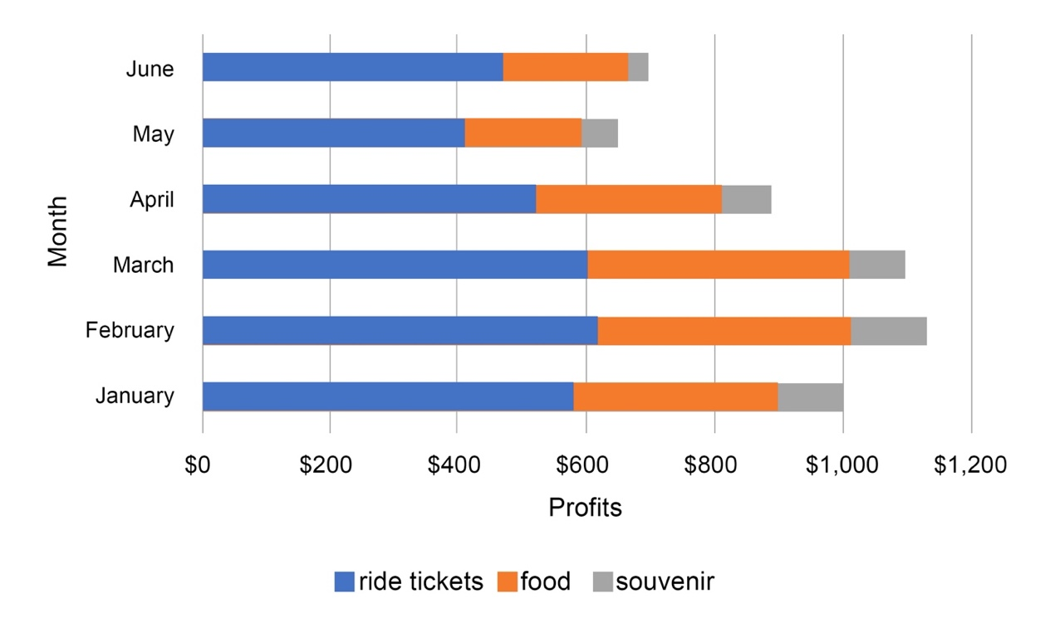
Caption: Funfair profits.
Alt text: A stacked bar graph shows the profits for a funfair broken up by month (January to June) and by type (ride tickets, food, and souvenirs). Each month, most of the profits come from ride tickets, with only a small amount coming from souvenirs. February is the most profitable month; May is the least profitable.
Long description: The y-axis of the bar chart shows the month, and the x-axis shows the profits. The following values are all approximate.
- In January, the funfair earned $550 from ride tickets, $300 from food, and $100 from souvenirs.
- In February, the funfair earned $600 from ride tickets, $400 from food, and $120 from souvenirs.
- In March, the funfair earned $580 from ride tickets, $400 from food, and $100 from souvenirs.
- In April, the funfair earned $500 from ride tickets, $300 from food, and $100 from souvenirs.
- In May, the funfair earned $400 from ride tickets, $180 from food, and $80 from souvenirs.
- In June, the funfair earned $450 from ride tickets, $180 from food, and $50 from souvenirs.
- For diagrams provide the information in a bullet list.
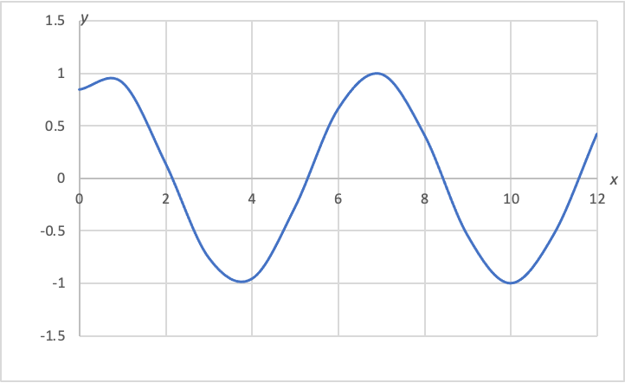
Caption: y = sin(x + 1)
Alt text: A graph of a sine wave shows an amplitude of 2 and a period of 2π.
Long description: A graph showing a mathematical function. Values on the x-axis range from 0 to 12. Values on the y-axis range from −1.5 to 1.5.
- A y-intercept is at 0.84.
- x-intercepts are at 2.14, 5.28, 8.42, and 11.57.
- Local maximums are at approximately x = 1 and x = 7. The maximum values are at approximately y = 1.
- Local minimums are at approximately x = 4 and x = 10. The minimum values are at approximately y = −1.
- For scatter plots, focus on the main trend of the data if the location of specific data is not required, as this would be evident to a sighted user.
- Spell out units in full (for example, kilometers rather than km), to aid comprehension and avoid any potential confusion.
- Order the information logically (for example, for pie charts, list the numbers from largest to smallest).
- If the image is for an educational text, ensure the terminology used is appropriate to the learning level, matches the vocabulary in the surrounding text and does not introduce terms or concepts that students haven’t learned yet.

This guide is adapted from Julie Ganner, Agata Mrva-Montoya, Maryanne Park, and Kayt Duncan, Books without Barriers (Ultimo: Australian Publishers Association, 2023).

